Assignment -4

SMS Spam Classification

| Assignment Date | 08 October 2022 |
| --- | --- |
| Team ID | PNT2022TMID27826 |
| Project Name | AI-powered Nutrition Analyzer for Fitness Enthusiasts |
| Student Name | SANJANA.S |
| Student Roll Number | 311519104050 |
| Maximum Marks | 2 Marks |

# **1.Download the dataset**

2.Import required library

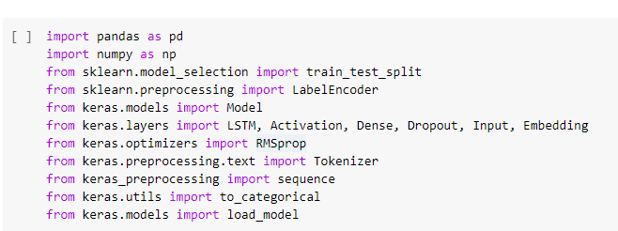

3.Read Dataset and do preprocessing

df = pd.read_csv('/content/spam (1).csv',delimiter=',',encoding='latin-1')

df.head()

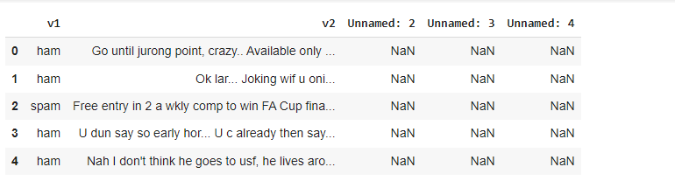

df.drop(['Unnamed: 2', 'Unnamed: 3', 'Unnamed: 4'],axis=1,inplace=True) #dropping unwanted columns

df.info()

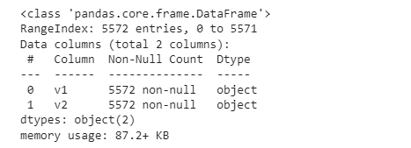

# Count of Spam and Ham values

df.groupby(['v1']).size()

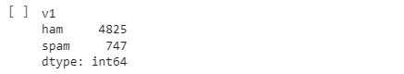

# Test and train split

X_train,X_test,Y_train,Y_test = train_test_split(X,Y,test_size=0.15)

# Label Encoding target column

X = df.v2

Y = df.v1

le = LabelEncoder()

Y = le.fit_transform(Y)

Y = Y.reshape(-1,1)

# Tokenisation function

max_words = 1000

max_len = 150

tok = Tokenizer(num_words=max_words)

tok.fit_on_texts(X_train)

sequences = tok.texts_to_sequences(X_train)

sequences_matrix = sequence.pad_sequences(sequences,maxlen=max_len)

4.Create Model and 5. Add Layers (LSTM, Dense-(Hidden Layers), Output)

# Creating LSTM model

inputs = Input(name='InputLayer',shape=[max_len])

layer = Embedding(max_words,50,input_length=max_len)(inputs)

layer = LSTM(64)(layer)

layer = Dense(256,name='FullyConnectedLayer1')(layer)

layer = Activation('relu')(layer)

layer = Dropout(0.5)(layer)

layer = Dense(1,name='OutputLayer')(layer)

layer = Activation('sigmoid')(layer)

6.Compile the model

model = Model(inputs=inputs,outputs=layer)

model.summary()

model.compile(loss='binary_crossentropy',optimizer=RMSprop(),metrics=['accuracy'])

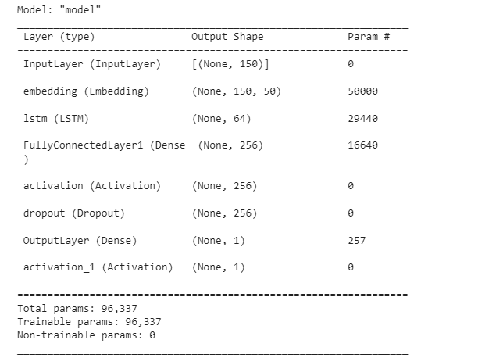

7.Fit the Model

model.fit(sequences_matrix,Y_train,batch_size=128,epochs=10,

validation_split=0.2)

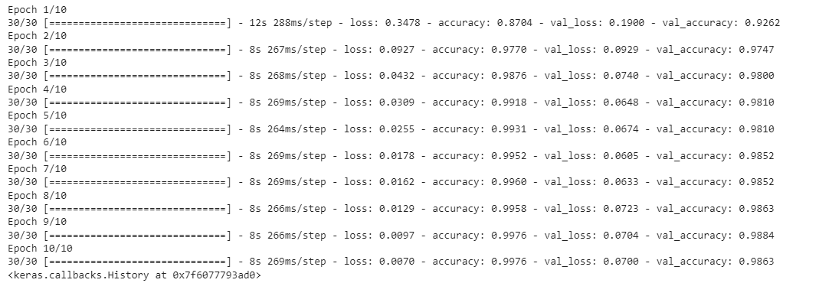

8.Save the Model

model.save("model_1")



9.Test the model

test_sequences = tok.texts_to_sequences(X_test)

test_sequences_matrix = sequence.pad_sequences(test_sequences,maxlen=max_len)

accuracy = model.evaluate(test_sequences_matrix,Y_test)

print('Accuracy: {:0.3f}'.format(accuracy[1]))



y_pred = model.predict(test_sequences_matrix)

print(y_pred[25:40].round(3))

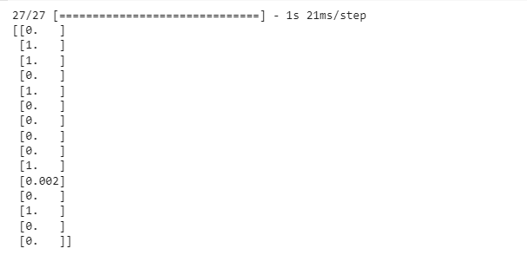

print(Y_test[25:40])

